**AWS IAM**

**AWS IAM Assignment**

1.Create a new IAM user with programmatic access only and generate an access key and secret access key.

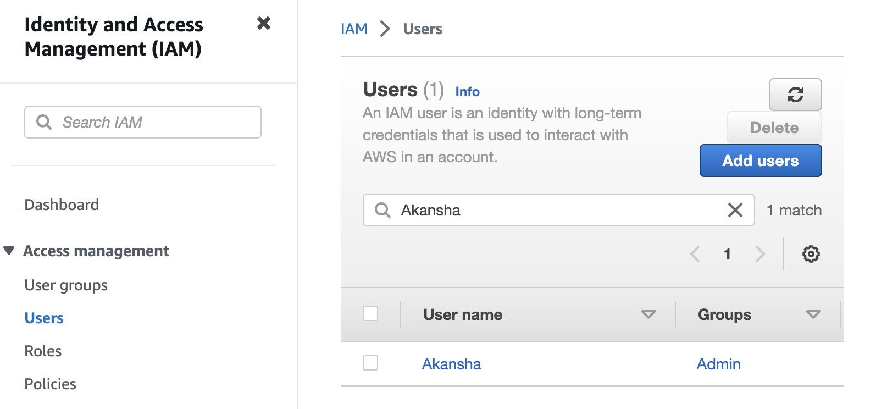

****************************************************

3. Create an IAM group and add the user to it. Launch an EC2 instance and assign the IAM role to it.

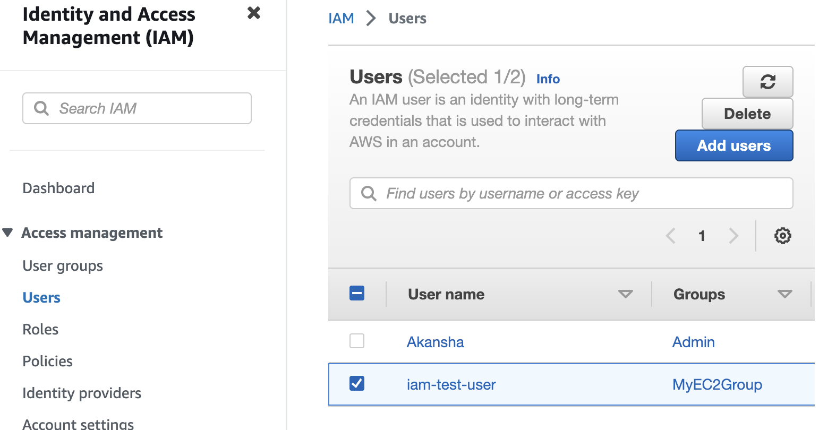

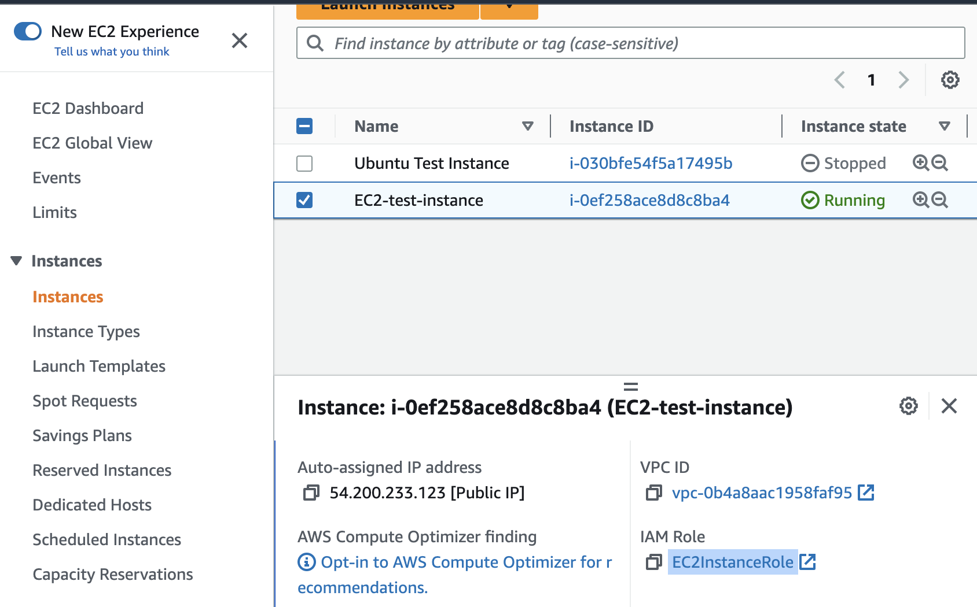

**\*\*\*\*\*\*\*\*\*\*\*\*\*\*\*\*\*\*\*\*\*\*\*\*\*\*\*\*\*\*\*\*\*\*\*\*\*\*\*\*\*\*\*\*\***

4. Create an IAM policy that allows read-only access to an S3 bucket and attach it to a group.

********************************************************

5. Create an IAM policy that denies access to an S3 bucket and attach it to a user, group, or role.

